Teepee Fever
Registration 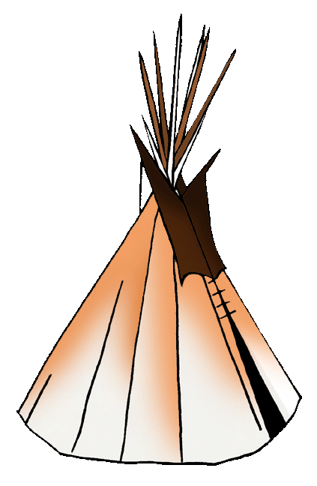

Stone Child College
Tribal Extension Program

To register for any of the Teepee fever workshops please fill out this registration form and drop it off at Stone Child College Sitting Old Woman Hall room 205 to Grant Manager Candace Morsette. Please circle the Educational Workshops that you will be attending.

Name: _________________________________________________________________________

Phone Number: __________________________________________________________________

Age Group: 18-29 30-39 40-49 50+

Gender: Male Female

Ethnicity:

Educational informal Workshops Day 1: July 23, 2018

Gardening Part 2 Water Testing Computers Part 2
9:00 a.m. -9:50 a.m. 9:00 a.m. -9:50 a.m. 9:00 a.m. - 4:00 a.m.

Social Service Overview Soil Mapping SORNA Presentation
10:00 a.m. - 10:50 a.m. 10:00 a.m. -10:50a.m. 11:0 a.m. -12:00 p.m.

Community Gardening Part 2 Entrepreneurship and Intro to Small Business
11:00 a.m. -12:00 p.m. 1:00 p.m. - 4:00 p.m.

Budgeting 101 Domestic Violence Prevention Initiative
1:00 p.m. -2:50 p.m. 3:00 p.m. - 4:00p.m.

Educational informal Workshops Day 2: July 24, 2018

Water Testing Sweet Grass Presentation
9:00 a.m. - 9:50 a.m. 9:00 a.m. -12:00 p.m.

How to Enhance Your Search Engine Skills Part 2 Different Styles of Dancing
10:00 a.m. -12:00 p.m. 1:00 p.m. – 4:00 p.m.

Historical Trauma/ SAMSHA Presentation
1:00 p.m. – 2:50 p.m.

Educational informal Workshops Day 3: July 25, 2018

Native Parenting Resume Writing
9:00 a.m. – 12:00 p.m. 9:00 a.m. – 12:00 p.m.

The classes that will have limited participants are:
You cannot register for these classes, will be served on a first come basis.

July 24, 2018 - Fleece Moccasins there will be 3 sessions each session there will be allowed 10 participants and will be served on a first come basis.

July 25, 2018 – Tie dying there will be 3 sessions each session there will be allowed 5 participants and will be served on a first come basis.

**Please note that registration starts at 8:30 a.m. and workshops will start at 9:00 a.m. on Monday July 23, 2018 at Kennewash Hall**

If you have question, comments or suggestions, please feel free to contact me Teepee Fever Grant Manager Candace Morsette at 406-395-4313 ext 221 or e-mail me at clmorsette@stonechild.edu

